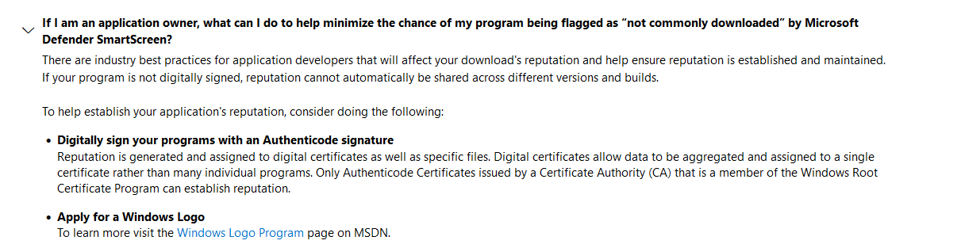

<https://techcommunity.microsoft.com/t5/windows-hardware-certification/bg-p/WindowsHardwareCertification>

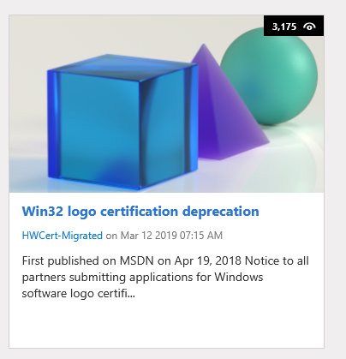

<https://techcommunity.microsoft.com/t5/windows-hardware-certification/win32-logo-certification-deprecation/ba-p/364920>

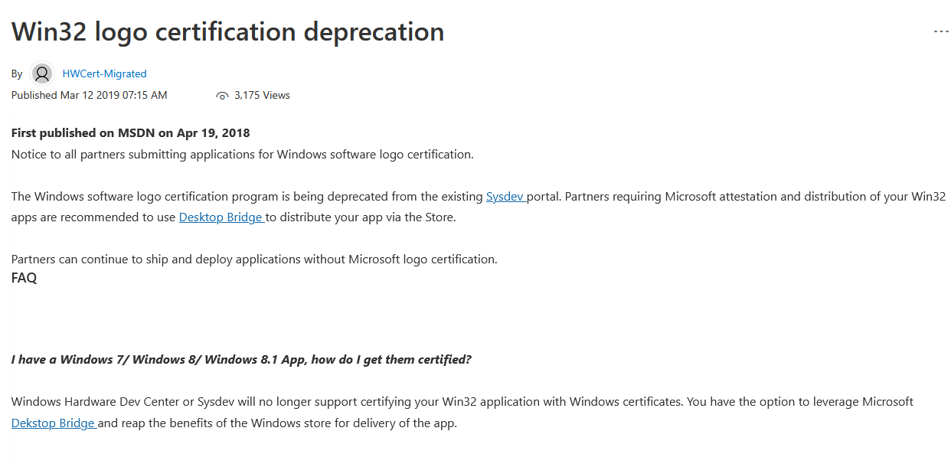

Windows Hardware Dev Center or Sysdev will no longer support certifying your Win32 application with Windows certificates. You have the option to leverage Microsoft [Dekstop Bridge](https://docs.microsoft.com/en-in/windows/uwp/porting/desktop-to-uwp-root) and reap the benefits of the Windows store for delivery of the app.

***I have concerns regarding this change, who do I contact?***   
  
Please contact win32submissions@microsoft.com for any concerns regarding this feature/certification program change.

<https://www.osnews.com/story/131873/microsoft-defender-smartscreen-is-hurting-independent-developers/>

<https://www.beholdgenealogy.com/blog/?p=3823>

https://news.ycombinator.com/item?id=23392404

|  |  |  |  |
| --- | --- | --- | --- |
| |  |  |  | | --- | --- | --- | |  |  | [acaloiar](https://news.ycombinator.com/user?id=acaloiar) [on June 2, 2020](https://news.ycombinator.com/item?id=23394180) | [parent](https://news.ycombinator.com/item?id=23392404#23393724) | [prev](https://news.ycombinator.com/item?id=23392404#23393984) | [next](https://news.ycombinator.com/item?id=23392404#23394230) [[–]](javascript:void(0))  > What can Microsoft do, as an alternative, that doesn't result in an identical or worse situation?  Microsoft can recognize that pay-to-play certificates are merely assets owned by developers; not developer identities. Microsoft needs to manage identity relationships with developers in a way that is indepdent of certificate aquisition and expiry.  The certificates themselves are merely an implementation detail of identity.  With that said, I don't condone the corporate gate-keeping of software development and recommend developers not contribute to any platform that requires indie developers to pay to become a part of the ecosystem. Long live open source. | |
| |  |  |  | | --- | --- | --- | |  |  | [mkup](https://news.ycombinator.com/user?id=mkup) [on June 2, 2020](https://news.ycombinator.com/item?id=23394230) | [parent](https://news.ycombinator.com/item?id=23392404#23393724) | [prev](https://news.ycombinator.com/item?id=23392404#23394180) | [next](https://news.ycombinator.com/item?id=23392404#23393855) [[–]](javascript:void(0)) | |